**High Level Requirements**

1. Application will maintain the details of all club members who have registered for the membership.
2. Based on Membership type club members will be able to avail various facilities in the club.
3. A person can register for the membership and can update their details.
4. Admin can manage types of memberships

**Low Level Requirements**

1. Regular, Premium and Gold Membership type.
2. Validity of membership based on type of Membership.
3. On registration, a membership id will be generated for the person who has successfully registered for the club.
4. Admin can add new membership schemes, modify existing schemes and remove any membership schemes.
5. A member can also view the expiry date of membership and can also check the number of days or month left.

**High Level Design**

1. Use Case Diagram

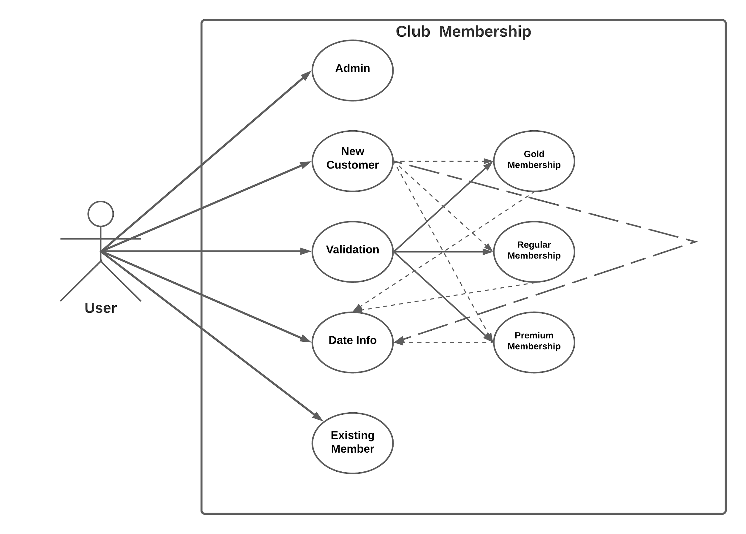

1. Activity Diagram

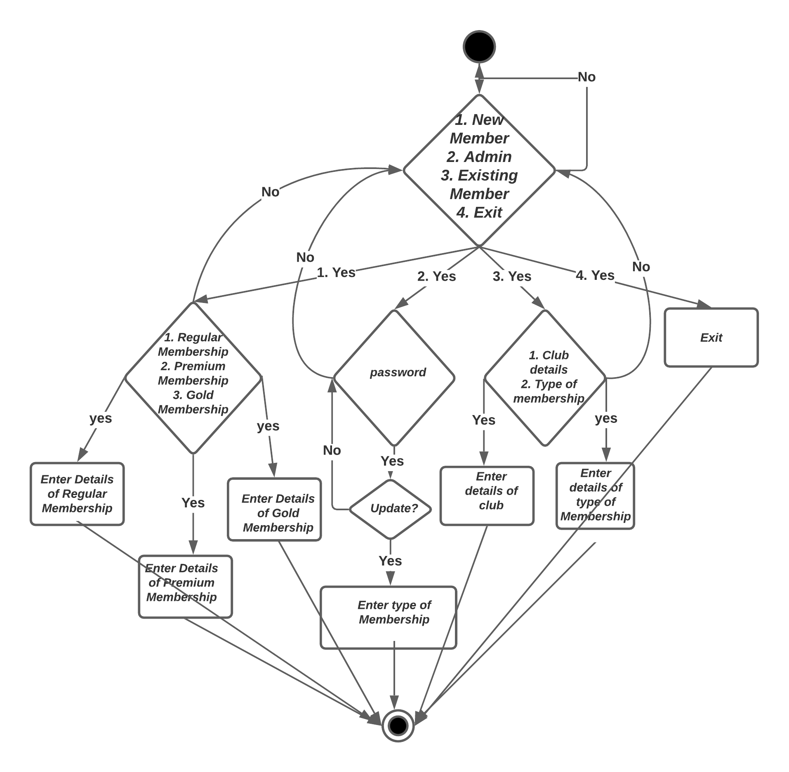

**Low Level Design**

Class Diagram

